Clarification on Ethernet: MII, SGMII, RGMII and PHY
1. Introduction
In this tutorial, we’ll talk about ethernet interfaces MII, SGMII, RGMII, and PHY.
2. Ethernet and Its Various Layers
Ethernet, a set of computer networking technologies, is widely employed in both local area networks (LANs) and metropolitan area networks (MANs). It delineates the physical and data link layers within the OSI model and is extensively utilized for wired networking. The simplicity, scalability, and widespread adoption of Ethernet technology distinguish it within the realm of computer networking.
Ethernet operates across two primary layers of the OSI model: the Physical Layer (Layer 1) and the Data Link Layer (Layer 2). These layers define how data is physically transmitted over the network medium and how devices on the network communicate with each other.
2.1. Physical Layer
The physical layer of Ethernet concerns itself with the tangible aspects of network communication, including the physical medium, cables, connectors, signaling methods, and the actual transmission of binary data.
It establishes the foundation for higher-layer protocols to communicate over a network, ensuring the reliable transmission of data between devices. It’s the lowest layer in the OSI model, and in the context of Ethernet, it deals with the actual transmission and reception of raw binary data over a physical medium.
2.2. Data Link Layer
The Data Link Layer of Ethernet performs several critical functions to facilitate reliable communication between devices on a network. The MAC sublayer manages addressing, frame formatting, and collision management, while the LLC sublayer handles flow control, error detection, and protocols like ARP. These functions collectively frame and address data for error-free communication over the physical medium within the local network.
The image below illustrates a clear understanding of the relationships between Ethernet interfaces MII, SGMII, RGMII, and PHY:
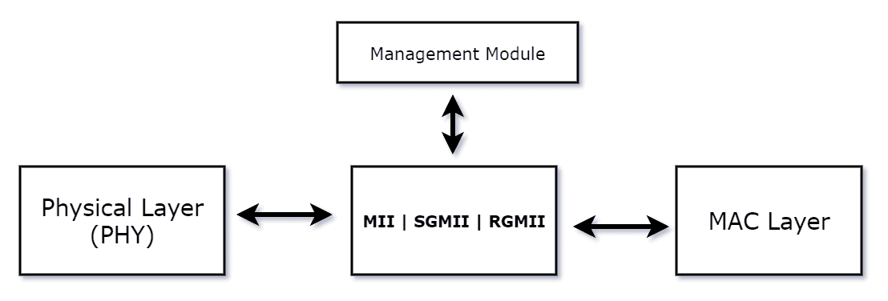
3. What Is MII (Media Independent Interface)?
The Media Independent Interface (MII) functions as a standardized interface within Ethernet devices, facilitating communication between the Media Access Control (MAC) sublayer and the physical layer (PHY). By establishing a consistent method for data exchange, MII fosters smooth collaboration between Ethernet controllers and PHYs, even when originating from different manufacturers.
This standardized approach has found broad acceptance in diverse Ethernet applications, particularly in the realms of Ethernet controllers, switches, and network interface cards (NICs). Its widespread use promotes interoperability and streamlines the integration of diverse components within Ethernet systems.
3.1. Role of MII in Connecting Network Devices
MII provides a standardized method for communication, ensuring that Ethernet controllers and PHYs can seamlessly exchange data. This standardization is essential for interoperability, allowing devices from different manufacturers to work together effectively.
It includes a shared clock signal that synchronizes data transmission between the MAC and PHY. Sync is necessary to ensure that data is sent and received at the right times, prevent errors and collisions, and guarantee these things.
3.2. Characteristics of MII
MII is media-independent and compatible with cables (twisted pair, fiber optic) and wireless connections. This flexibility allows for the adaptation of Ethernet to different network environments.
It operates as a parallel interface, transmitting and receiving multiple bits simultaneously. This characteristic contributes to the high-speed data transfer capabilities of MII, especially in comparison to serial interfaces.
4. Definition of SGMII (Serial Gigabit Media Independent Interface)
SGMII is a serial interface standard designed to provide a high-speed, point-to-point connection between the Ethernet MAC (Media Access Control) sublayer and the Ethernet PHY (Physical Layer).
Primarily employed in Gigabit Ethernet (GbE) and Fast Ethernet (FE) applications, favoring a serial communication link over traditional parallel interfaces.
4.1. Role of SGMII
For quick communication between the Physical Layer (PHY) and the Media Access Control (MAC) sublayer in Ethernet devices, SGMII is necessary.
Compared to parallel interfaces like Gigabit Media Independent Interface (GMII), SGMII has a reduced pin count. This reduction in the number of signal lines simplifies board designs, saves space, and makes it more practical for devices with limited physical space.
4.2. Characteristics of SGMII
SGMII employs differential signaling, transmitting information using pairs of signals with opposite voltage polarities. This approach helps in reducing electromagnetic interference and enhancing signal integrity.
It supports auto-negotiation, allowing connected devices to automatically configure their link parameters, such as speed and duplex mode. Auto-negotiation helps ensure optimal communication between devices.
It provides mechanisms for detecting link status and error detection, which is crucial for a reliable connection’s quality monitoring.
5. Definition of RGMII
The Reduced Gigabit Media Independent Interface (RGMII) is a standard interface employed in Ethernet devices to streamline communication between the MAC sublayer and the Physical Layer.
Tailored for Gigabit Ethernet (GbE) applications, RGMII offers a more concise and simplified interface when contrasted with the original Gigabit Media Independent Interface (GMII).
5.1. Role of RGMII
The role of RGMII lies in providing a high-speed interface between the Ethernet MAC (Media Access Control) and PHY (Physical Layer) components in network systems.
It’s designed for applications where board space is a critical factor, aiming to optimize designs in scenarios where traditional interfaces may be impractical.
It maintains compatibility with GMII, allowing for interoperability between devices using RGMII and GMII interfaces.
5.2. Characteristics of RGMII
One of the defining features of RGMII is its reduced pin count compared to the original Gigabit Media Independent Interface (GMII). This reduction in the number of pins simplifies board designs and is particularly advantageous for devices with space constraints.
It facilitates more compact and cost-effective circuit board designs, making it well-suited for modern networking devices where efficient use of space is essential.
RGMII supports auto-negotiation, allowing connected devices to automatically configure their link parameters, such as speed and duplex mode. Auto-negotiation simplifies the process of establishing optimal communication settings.
6. Definition and Role of PHY
The Physical Layer (PHY) is a crucial component of the OSI (Open Systems Interconnection) model, responsible for managing the physical connection between network devices. Manages raw binary data transmission and reception over the physical medium, encompassing cables, fibers, or wireless transmission.
The PHY layer handles tasks such as encoding, modulation, signaling, and electrical or optical specifications necessary for the actual transmission of data between devices on a network.
It determines the bit rate at which data is transmitted over the physical medium to regulate the flow of data between devices, optimizing communication efficiency.
7. Summary
Let’s summarize the main differences:
 | Nature | Data Transfer
MII | Parallel interface used for communication. | It operates with multiple data lines.
SGMII | Serial interface designed for high-speed communication. | Functions as a serial interface, transmitting data sequentially.
RGMII | RGMII is a reduced-pin-count variant of GMII. | Cuts pin count versus original GMII for smaller board designs.
PHY | It’s a physical layer in the OSI model. | Handles raw binary data transmission, including encoding, modulation, and clock synchronization.

 | Application/Advantages
MII | Commonly used in Fast Ethernet.
SGMII | Fewer pins, space-efficient, and compatible with various PHY devices.
RGMII | Maintains GMII compatibility for RGMII and GMII device interoperability.
PHY | Enabling communication between the MAC layer and the physical transmission medium

8. Conclusion
In this article, we discussed MII, SGMII, RGMII, and PHY related to ethernet. Crucial for networking professionals: grasp the intricacies of these interfaces for effective work in networking and communications. PHY facilitates communication between the MAC and the physical layer, and MII facilitates communication between the Media Access Control (MAC) sublayer and the physical layer (PHY).
SGMII is a serial interface standard created to establish a high-speed, point-to-point link between the Ethernet MAC (Media Access Control) sublayer and the Ethernet PHY (Physical Layer).

